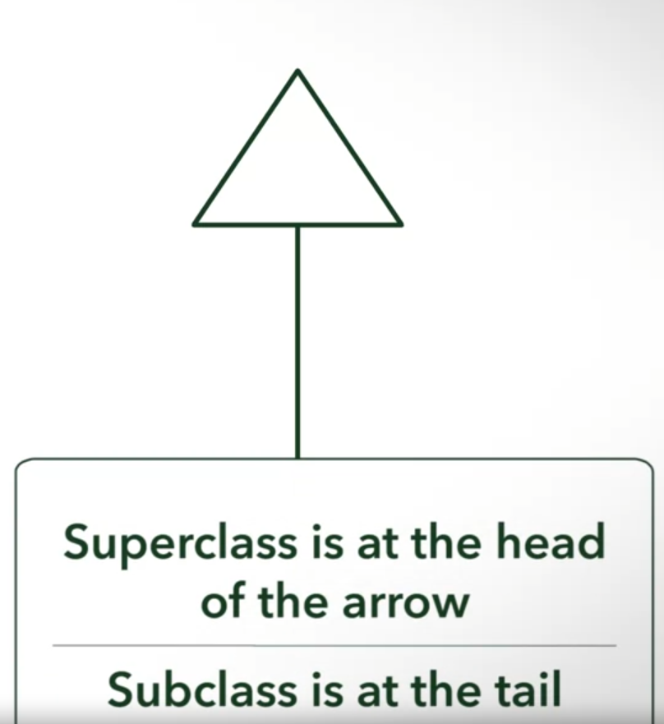

 

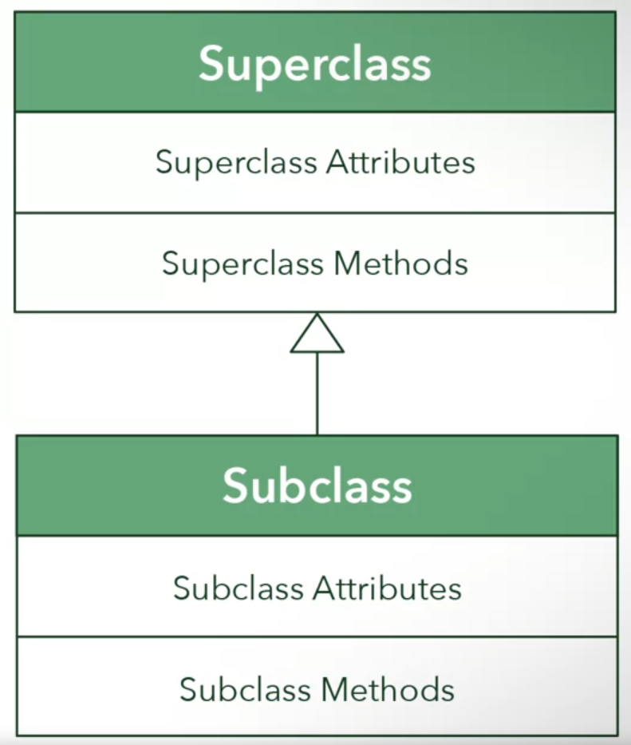









Java code



* Abstract means this class cannot be instantiated





* Notice we do not declare any inherited attributes in our subclass both in UML Diagram and Java code

Constructors

* Use to instantiate objects

Implicit constructor



Explicit constructor





Subclass can override methods of superclass



Question

You are a developer in charge of creating different methods of travel in a video game. The team has decided to give the player various options for transportation, which include: riding a horse, driving a car, or flying a plane. You have decided that you will generalize these modes of transportation into an abstract class called Transport.

**Which attributes and behaviors would you include in your general class?**



Types of inheritance





* In Java

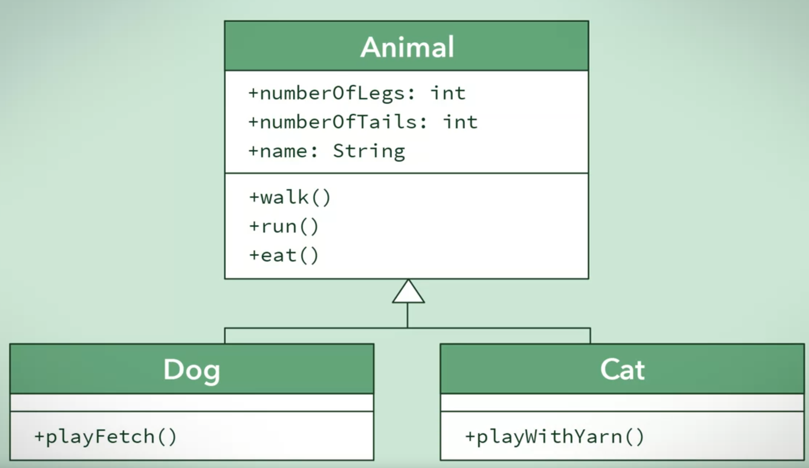



* Specialized classes
* Subclass can also be superclass to another class